**Stakeholder & User Needs:**

We carried out market research to identify stakeholders who could benefit from our concept idea.

Arianna interviewed several stakeholders who have a keen interest in gardening (a copy of the transcripts can be found in the appendix). We developed personas and typical scenarios for each stakeholder which will support us when making design decisions and remind us of the stakeholder’s requirements. Each scenario highlights the responses we received from the stakeholders (figures 1, 2 and 3).

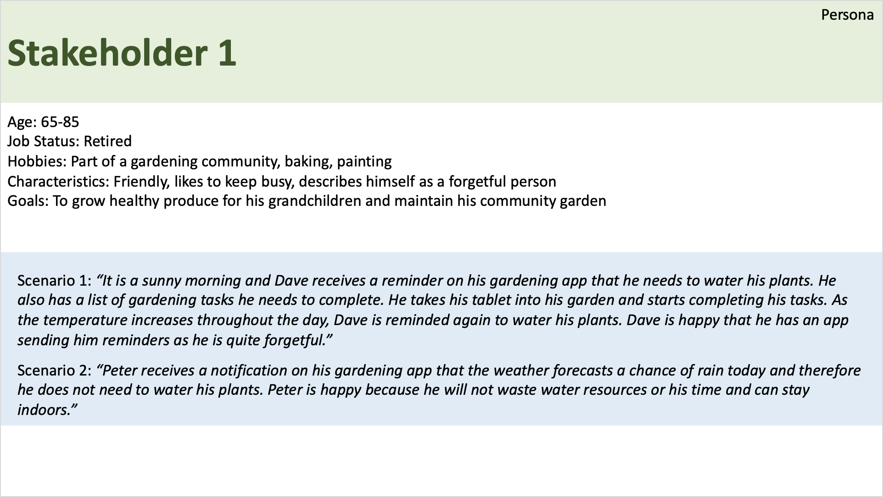

***Figure 1***

Stakeholder 1 is confident that this app will raise awareness on garden conservation.

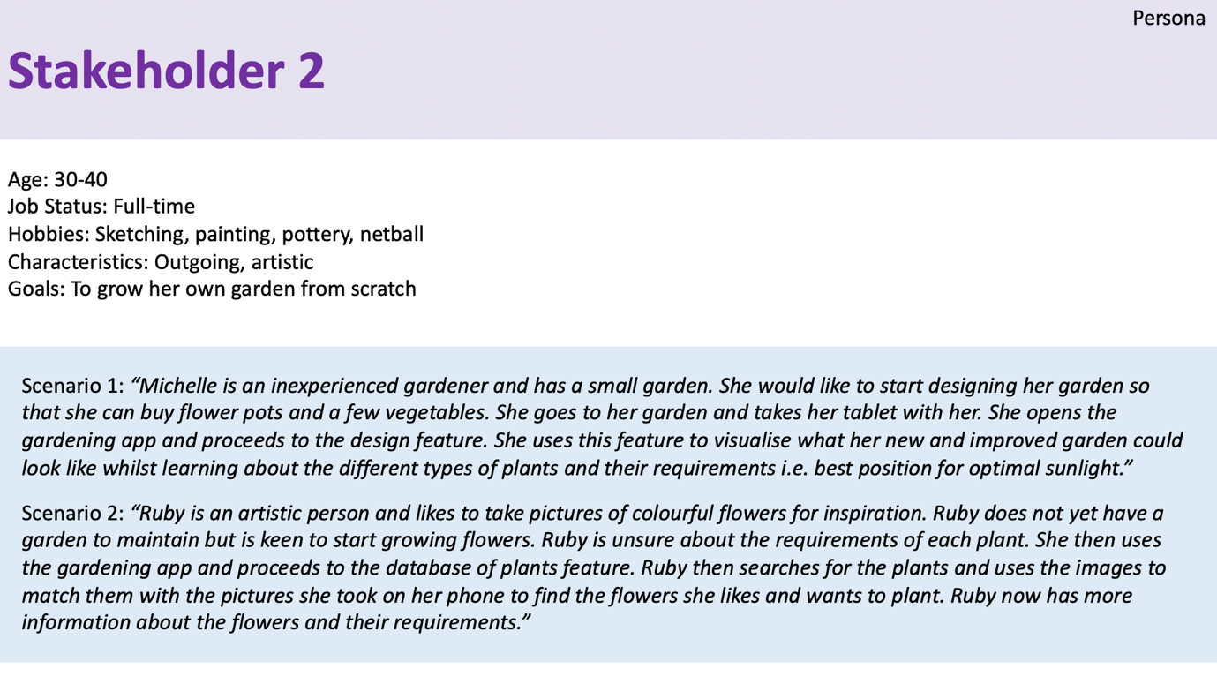

***Figure 2***

Stakeholder 2 would find this app extremely useful in managing her gardening tasks and shows strong interest in the drawing feature.

Arianna found another stakeholder when testing the low-fidelity prototypes.

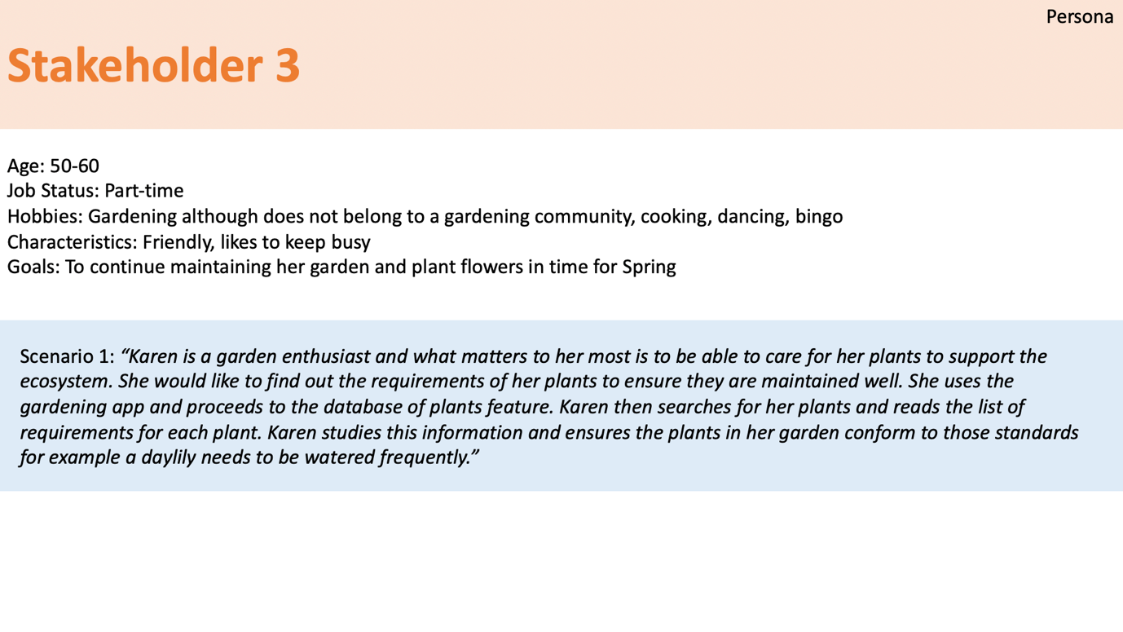

***Figure 3***

Stakeholder 3 came across an article which highlighted the significant increase of plant extinction through lack of care and maintenance (a copy of the article can be found in the appendix) and is confident this app could prevent this continual act which has allowed our project to have greater cause.

An accessibility feature which must be focused on is to design the app with the elderly in mind to ensure it is user-friendly and easy to access.

These interviews confirmed that an app to assist gardeners would be extremely useful. The idea of having a drawing, database of plants and reminder features were received positively and defined our usability goals which would enhance user experience. Neither of the stakeholders had heard of a gardening assistant application.

**Prior Knowledge & Market Survey:**

We undertook market research to explore whether there could be a wider demographic for our product and analysed existing products on the market.

Taylor distributed a survey to collate quantitive feedback (figure 4) from a variety of people to help us understand how our app would be received. We discovered a strong approval for our app and identified a wider demographic.

***Figure 4***

Khari researched existing products on the market that have a similar concept to ours.

‘SmartPlant’ (figure 5) uses a library of plant information and sends notifications to users of their tasks. However, our concept will enable users to design the layout of their garden.

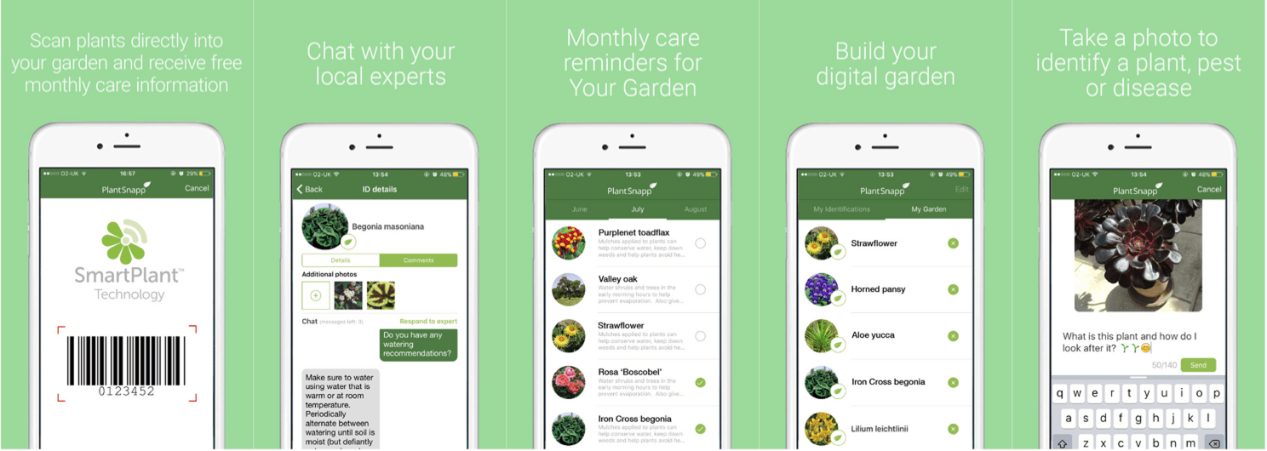

***Figure 5***

‘Moon and Garden’ (figure 6) provides similar features to our proposed concept such as advising users on how to maintain their garden and examines the moon phases to provide weather updates. In contrast, our concept will use local weather updates to provide an up-to-date calendar.

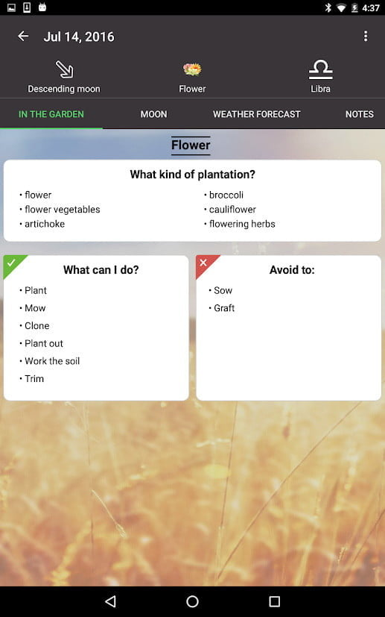

***Figure 6***

‘Gardenate’ (figure 7) informs users which plants are currently in season whereas our concept allows users to search through a database of plants and examine their requirements.

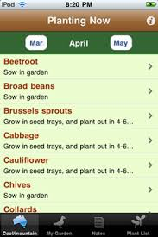

***Figure 7***

Computer Science problems presented by our project are as follows:

* Up-to-date plant information
* Populate a calendar with tasks and create alerts
* Design your own garden

We will apply computational thinking such as abstraction and modularity when designing and implementing a moderately complex computing system to achieve our desired result.

In conclusion, we have established there is a strong demand for our concept and have identified a gap in the market for a fully functional gardening app which can accommodate and support the needs of a variety of stakeholders.